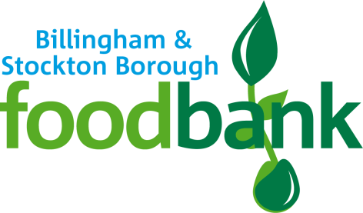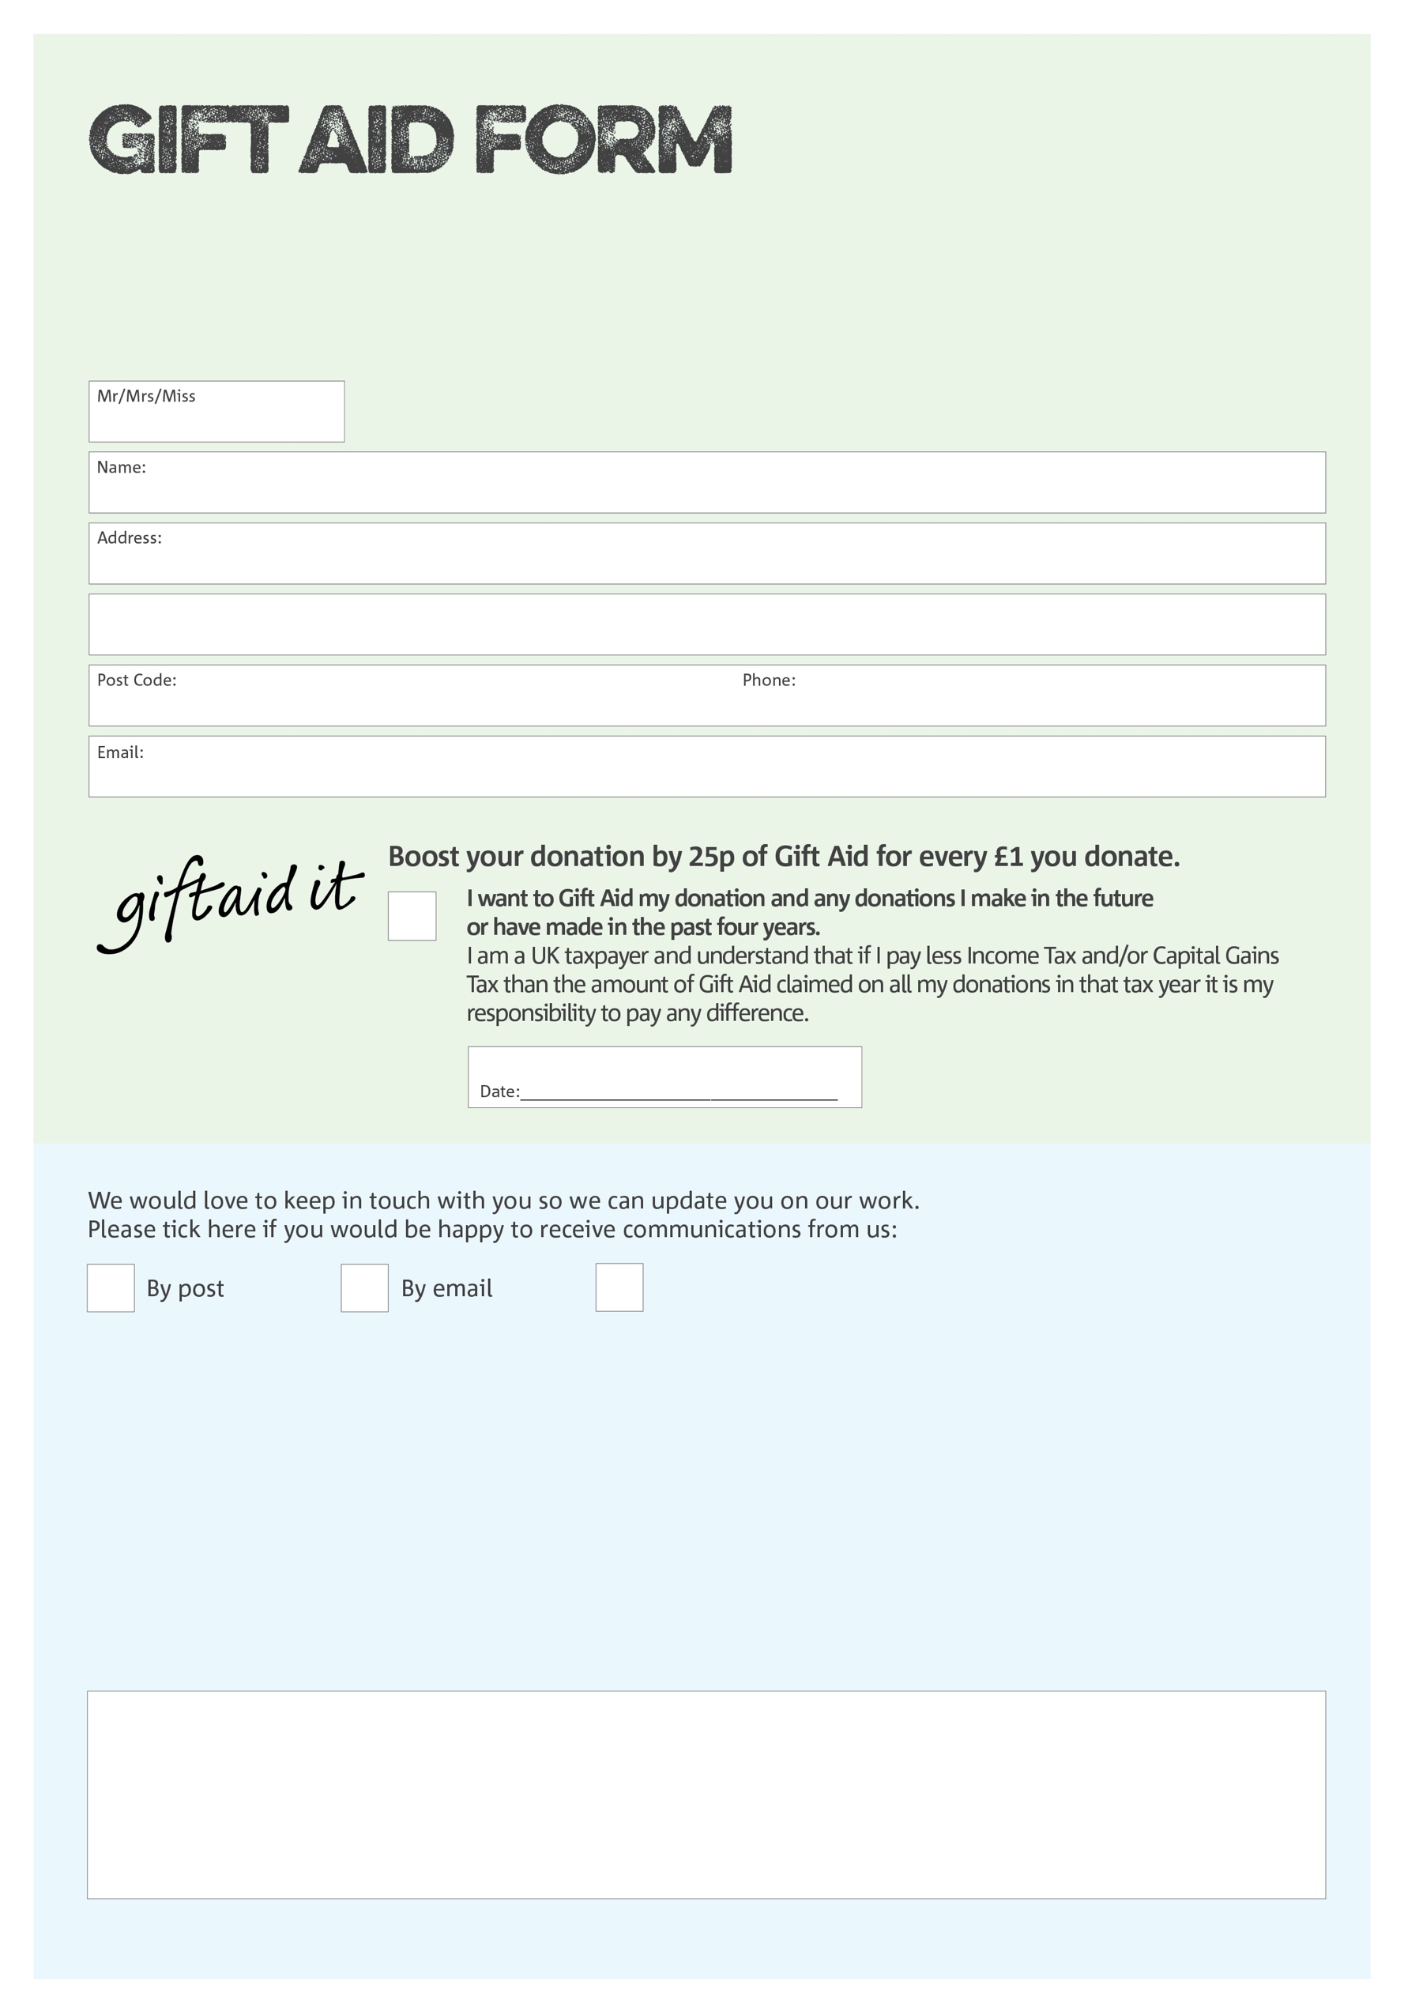

By filling in this form Billingham & Stockton Borough Foodbank will receive an extra 25p for every £1 you give at no extra cost to you. Thank you!

I do not wish to receive future communications from   
Billingham & Stockton Borough Foodbank

Charity Number 1177777. Registered in England & Wales

You can change your preferences any time by contacting us on 07583 575 522 or emailing us at info@billinghamandstocktonborough.foodbank.org.uk

**Data protection***'Billingham & Stockton Borough Foodbank is committed to protecting your privacy and will process your personal data in accordance with current Data Protection legislation Billingham & Stockton Borough Foodbank collects information to keep in touch with you and supply you with information relating to our work. To unsubscribe from our newsletter, send a message to the email address above with the word unsubscribe in the subject line. A full data privacy statement for financial donors is available from the foodbank on request.’*

We would love to know why you have chosen to donate to Billingham & Stockton Borough Foodbank. If you would like to share your motivation let us know below: